|  |  |
| --- | --- |
|  | **| Automated Product Price Monitoring** |

Process Design Document

# Process Design Document History

|  |  |  |  |  |  |  |
| --- | --- | --- | --- | --- | --- | --- |
| **Date** | **Version Role** | | **Name** | **Organization** | **Function** | **Comments** |
| 30.04.2024 | 1.0 | Draft |  | 1Rivet Pvt Ltd | SME/MSP | Creation v 1.0 |
|  | 1.2 | Reviewer |  | 1Rivet Pvt Ltd | MSP | Approved v 1.0 |

# Table of Contents

Process Design Document History 1

1. Introduction 3

1.1 Purpose of the document 3

1.2 Objectives 3

1.3 Process key contacts 3

2. AS IS Process Description 4

2.1 Process overview 4

2.1.1 In scope for RPA 5

2.1.2 Out of scope for RPA 5

2.1.3 High Level Process Diagram 5

2.2 Detailed Process map 6

2.3 Detailed Process Steps 8

2.4 Exceptions handling 12

2.5 Error mapping and handling 13

2.6 In-Scope application details 13

3. Development details 14

3.1 Prerequisites for development 14

3.2 Password policies 14

4. Document Approval Flow 15

5. Appendix 16

5.1 UiPath automated process details 16

# 1. Introduction

## 1.1 Purpose of the document

The Process Design Document describes the business processes chosen for automation using the UiPath Robotic Process Automation (RPA) technology.

This document describes the sequence of steps performed as part of the process, as well as the conditions and requirements prior to its automation. This design document serves as a base documentation for developers to collect the details required for robotic automation of the same business process.

## 1.2 Objectives

This project aims to automate price monitoring and comparison across different e-commerce platforms, specifically Amazon and Flipkart.

The objective of this process automation is linked to the project business case and is mainly intended to:

* Enhance Price Monitoring Efficiency
* Reduce Manual Data Extraction and Analysis
* Improve Price Comparison and Reporting
* Augment User Productivity and Decision Support

## 1.3 Process key contacts

The Design Document includes a brief, but comprehensive set of requirements for the process. Its structure is based on the input provided by the Subject Matter Expert (SME) in the process.

|  |  |  |  |
| --- | --- | --- | --- |
| **Role** | **Name** | **Date of action** | **Notes** |
| Process SME |  | 30.04.2024 | 1. Search product on Amazon and FlipKart.  2. Extract similar products and compare  3. Create the brief report for the same. |
| Reviewer / Owner |  | TBD | POC for process exceptions |
| Approval for production |  | TBD | Escalations, Delays |

# 2. AS IS Process Description

## 2.1 Process overview

General information about the process selected for RPA implementation, prior to its automation:

|  |  |
| --- | --- |
| **AS IS process details** | |
| Process full name | Automated Product Price Monitoring |
| Function | Price Analyzer |
| Department | E-Commerce |
| Process short description | Check product prices on Amazon and Flipkart. Compares prices, generates a reports with the lowest price option, and sends an email notification. |
| Role required for performing the process | Simple User |
| Process schedule | Daily |
| # of item processes / day |  |
| Average handling time per item |  |
| Peak period (s) | No peak period |
| # of FTEs supporting this activity | 1 |
| Level of exception rate | No expected exceptions |
| Input data | Client Data |
| Output data | Price Comparison Reports |

### 2.1.1 In scope for RPA

The activities and exceptions in this process that are in the scope for RPA, are listed below:

* + - * Full Scope for RPA – the process is to be 100% automated.

### 2.1.2 Out of scope for RPA

There are no activities out of scope for RPA

### 2.1.3 High Level Process Diagram

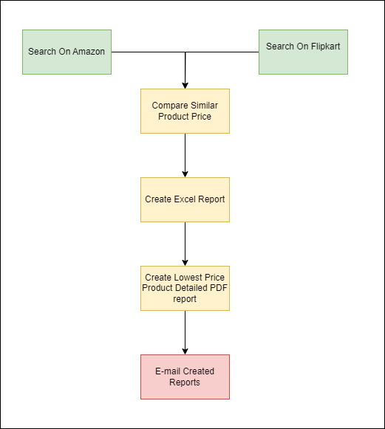

## 2.2 Detailed Process map

This chapter presents the chosen process in detail, which enables the developer to build the automated process.

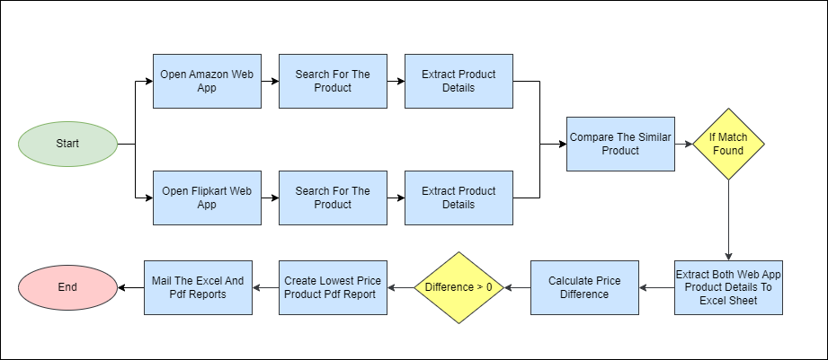

|  |  |  |  |  |  |
| --- | --- | --- | --- | --- | --- |
|  | **Short Description** | | | | |
| **1.1** | Open Amazon Web Application | | | | |
| **1.2** | Search for the product. | | | | |
| **1.3** | Get all the similar product based on search. | | | | |
| **2.1** | Open Flipcart Web Application | | | | |
| **2.2** | Search for the product. | | | | |
| **2.3** | Get all the similar product based on search. | | | | |
| **3.1** | For each product compare color, ram and storage from the both application. | | | | |
| **4.1** | If match for similar products found | | | | |
|  | **Yes** | | **No** | | |
| **4.2** | Calculate:   1. Price difference, 2. Change percentage | **4.3** | Continue with the other product to search for. | |
| **5.1** | Create the excel report with details of product item on amazon and flipkart respectively and the calculated difference | | | | |
| **6.1** | If price difference is zero | | | | |
|  | **Yes** | | **No** | | |
| **6.2** | Continue with rest matches | **6.3** | | Create the PDF report for the lowest price product item |
| **7.1** | Mail the excel report and PDF report. | | | | |

## 2.3 Detailed Process Steps

This include complete set of steps in the process, including keystrokes and clicks.

|  |  |  |  |  |
| --- | --- | --- | --- | --- |
| **#** | **Step action description** | **Screenshot** | **Expected result** | **Remarks** |
| **1.1** | Open Amazon Web Application  (https://www.amazon.in/) |  | Amazon Web to be opened | Handle any pop up appears in case.  Handle the layout change  **Possible Exception:**  Application Server down or application did not open |
| **1.2** | Search for the product |  | List of all the products with price and other related information. | **Possible Exception:**  Handle if no product is found |
| **1.3** | Get all the product based on search | N/A | N/A | Get only product that match our search |
| **2.1** | Open Flipkart Web Application  (https://www.flipkart.com/ |  | Flipkart Web to be opened | Handle any pop up appears in case.  Handle the layout change  **Possible Exception:**  Application Server down or application did not open |
| **2.2** | Search for the product and extract the similar product details |  | List of all the products with price and other related information. | **Possible Exception:**  Handle if no product is found |
| **2.3** | Get all the similar product based on search | N/A | N/A | Get only product that match our search |
| **3.1** | For each product compare price based on color, ram and storage from the both application | N/A | N/A | **Possible Exception:**  Handle the exception when no item on Amazon Match with items on Flipkart. |
| **4.1** | Match the similar products based on features | N/A | N/A | N/A |
| **4.2** | For matched product item Calculate :   1. Price Difference 2. Percentage Change | N/A | The price difference and percentage change in price of product item that matched |  |
| **4.3** | Continue with the rest of the product items if no match is found for the particular product item. | N/A | N/A | N/A |
| **5.1** | On Match of products add the details to excel sheet for that product search  Details contain:   1. Product item short description 2. Amazon Product URL, 3. Amazon Original price, 4. Amazon Discounted price, 5. Amazon Discount percentage 6. Flipkart Product URL, 7. Flipkart Original price, 8. Flipkart Discounted price, 9. Flipkart Discount percentage 10. Price difference, 11. Change percentage | N/A | Excel file that contains the details of product search items that appears on both application | Always create new excel report file for the process and archive the previous created file. |
| **6.1** | Watch the price difference calculated | N/A | Could be >= 0 | N/A |
| **6.2** | If the difference match is zero continue with rest matches | N/A | N/A | N/A |
| **6.3.** | On price difference value greater than zero of product item, create the detail report for the lowest price product item with details:   1. Short Descriptions 2. Product URL, 3. Application, 4. Original price, 5. Discounted price, 6. Discount percentage 7. Banks offer and Partner offer. 8. Photo | N/A | PDF Report file that contains details of the lowest price product item. | Always create the new pdf report file for each product item and archive the previous other file if any. |
| **7.1** | Mail the user with all the reports created during the process | N/A | N/A | N/A |

## 2.4 Exceptions handling

The types of exceptions identifiable in the automation process can be classified according to the table below.

|  |  |  |
| --- | --- | --- |
| **Area** | **Known** | **Unknown** |
| **Business** | Previously encountered situation. A possible scenario is defined, and clear actions and workarounds are provided for each case. | A situation never encountered before. It can be caused by external factors. |

Based on the above criteria, the table below should reflect all the known exceptions identified throughout the process and map the expected action the robot needs to take in each case.

|  |  |  |  |  |
| --- | --- | --- | --- | --- |
| **#** | **Exception**  **name** | **Step where exception is encountered** | **Parameters** | **Action to be taken** |
| **1** | No Product Found | Step #**1.2** and **2.2** | If message shows: On Amazon: *No results for “ProductName”.*  ON Flipcart:  *“Sorry, no results found!”* | Send Email to [xyz@example.com](mailto:xyz@example.com)  *“Hello,*  *No product available name “ProductName”.*  *Thank You”* |
| **2** | No any match found for any product item | Step #**3.1** | No data to add in excel sheet | Send Email to [xyz@example.com](mailto:xyz@example.com)  *“Hello,*  *No product on Amazon matched on flipkart.*  *Thank You”* |

For any other unanticipated or unknown exceptions, the robot should send an email notification at [xyz@example.com](mailto:xyz@example.com) with the original email and error message screenshot attached.

## 2.5 Error mapping and handling

A comprehensive list of all the errors, warnings, or notifications should be consolidated here with the description and action to be taken by the Robot in each case.

The errors identified in the automation process can be classified according to the table below.

|  |  |  |
| --- | --- | --- |
| **Area** | **Known** | **Unknown** |
| Technology | Experienced previously, action plan or workaround available for it. | New situation never encountered before, or may happened independent of the applications used in the process. |

Based on the above criteria, the table below should reflect all the identifiable errors in the process, and map the expected action of the Robot in each case.



|  |  |  |  |  |
| --- | --- | --- | --- | --- |
| **#** | **Error Name** | **Step where**  **error is encountered** | **Parameters** | **Action to be taken** |
| **1** | Application unresponsive/ page not loading | Any step | No response/ blank page | Retry 2 times. Close application and run the sequence again |
| **2** | Application Crash /  Internal Server Error | Any step | Error message | Refresh / Retry  Send email with screenshot to [xyz@example.com](mailto:xyz@example.com)  *“Close application and run the sequence again”* |

## 2.6 In-Scope application details

The table below lists all the applications that are used as part of the automated process.

|  |  |  |  |  |  |  |
| --- | --- | --- | --- | --- | --- | --- |
| **#** | **Application name & Version** | **Syst. Lang.** | **Login module** | **Interface** | **Environment/ Access method** | **Comments** |
| 1 | Amazon | EN | Web | Web | Web Browser |  |
| 2 | Flipcart | EN | Web | Web | Web Browser |  |
| 3 | Excel | EN | N/A | Client | Application |  |

# 3. Development details

## 3.1 Prerequisites for development

* + Development or testing environment are to be provided for development purposes.
  + The provided development and testing environments are exact replicas of the production environment.
  + Dedicated system and application access are given to developers with the adequate permissions.

## 3.2 Password policies

Users manage their own passwords. There are no special policies in place. The process can be done without logged in.

# 4. Document Approval Flow

|  |  |  |  |  |  |
| --- | --- | --- | --- | --- | --- |
| **Version** | **Flow** | **Role** | **Name** | **Organi zation (Dept.)** | **Signatur e and Date:** |
| **1.0** | Document prepared by: | Business Analyst |  |  |  |
| **1.0** | Document Approved by: | Business Process Owner |  |  |  |
| **1.0** | Document Approved by: | Dev/Automation Solution Architect |  |  |  |

# 5. Appendix

## 5.1 UiPath automated process details

**Note: this step is to be ﬁlled in after automation process is complete Automation overview**: (time to dev, test, etc)

**Robots type**: Back Oﬃce Robot

**Level of human intervention required**:

**Use of Orchestrator**:

**Exceptions recorded in automation process**: **Errors identiﬁed in the automation process**: **Challenges identiﬁed in the automation process**:

**Lessons Learned**:

**Any adjustments** made to facilitate the automation process and any steps taken to shift from the human way of working to the automatic one. Any activity performed to improve the As Is process and to enable higher rates of automation of the process:

* Process Assumption
* Input data assumption
* Number or types of input to be received
* Skipping the login interface and collecting backend details
* Extracting backend data without opening the file
* Data conversion/ formatting

**Reporting:** The details and format of the logging mechanism available in the workflow have to be specified here, whether it is a local log report or the Orchestrator log).

The format should be specified by the business users.

**Workflow and scripts:** A brief overview of each workflow and the sequence in which it is executed should be provided here.